Web Scrapping:

In this project we have done web scrapping using python BeautifulSoup library.

The link of the website being scrapped is below:

<https://parivahan.gov.in/rcdlstatus/vahan/rcDlHome.xhtml>

Our aim of this project is to create a simple web UI, were we will give the basic vehicle details and then it show the exact information which are being showed in the ‘parivahan’ govt website.

First of all, we will see the normal parivahan website and how it works step by step in below:

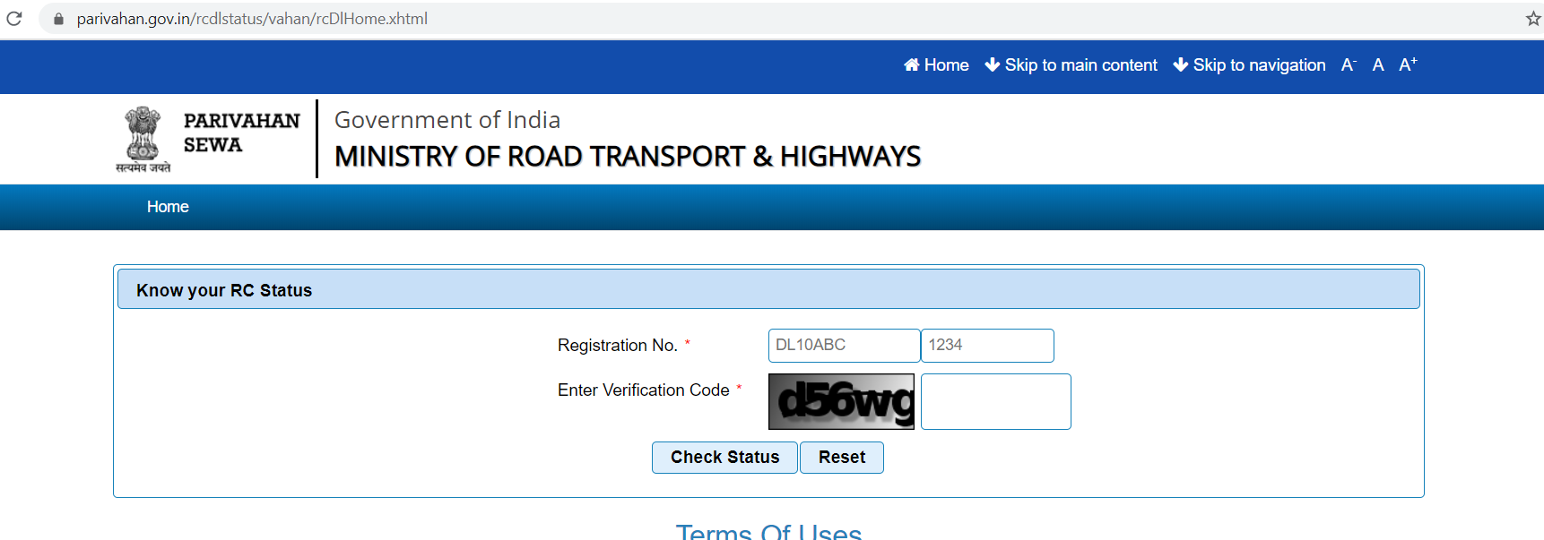

Here you have to give the vehicle registration number and all, including the captha(See below image). In our web UI we won’t have the captha.

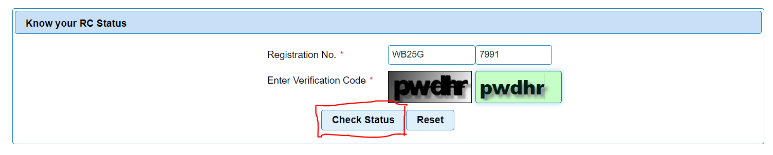

After providing basic vehicle details you have click the ‘check status’ button to see the RC status of the vehicle, the result will be something like this –

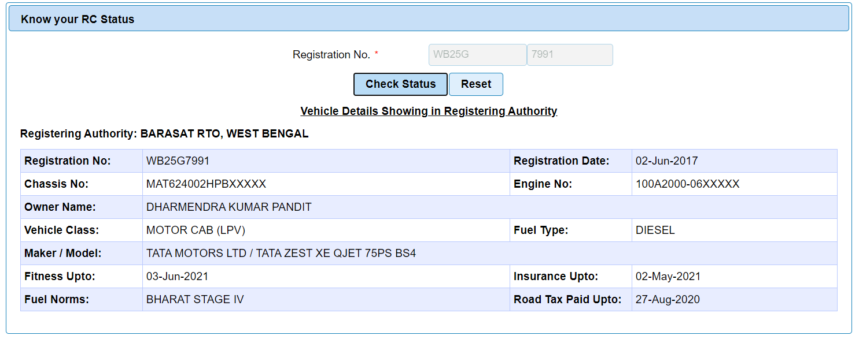

Now, in our website we will do the same thing, but without using the ‘captha’ with the help of web scrapping using the BeautifulSoap library.

Web link: <https://vehicleinfo-timely-bear-sx.cfapps.io/>

Once you open the website you will get this type of view –

**Step 1** :

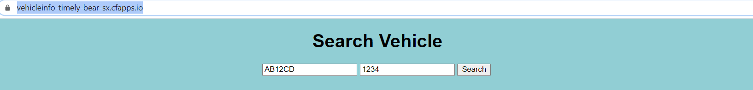

N.B: initially opening the page the two textboxes will be having some generic values please don’t use those, remove them and provide your own real Vehicle number which is registered under Govt. of India.

**Step 2** : provide the basic vehicle details in the text boxes, remember the first 5 alphanumeric characters should be entered in first textbox(left hand side) and the numeric part(last 4 digits) will be entered in the second textbox. Once given, press the ‘search’ button.



Step 3 :

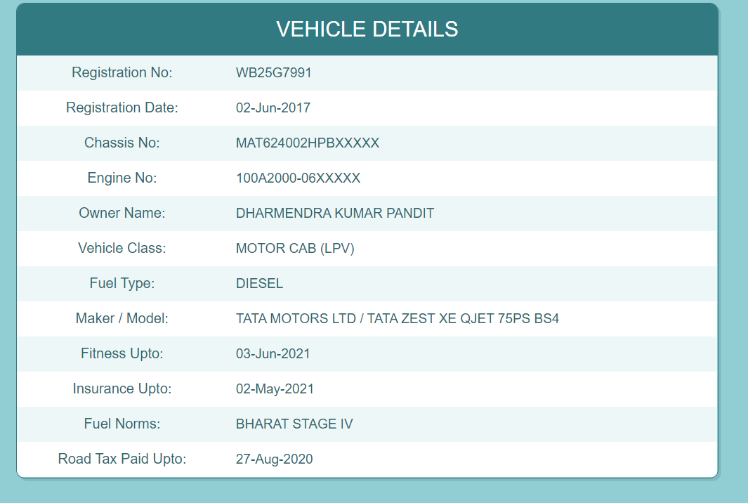

This project is hosted pivotal cloud platform, the website link of the project is: <https://vehicleinfo-timely-bear-sx.cfapps.io/>

The code is available in github in the below address: <https://github.com/Sghosh023/Web_Scrapping_Vehicle_Info>